

**“SHAKES-SHARE” – London, 11-13th November, 2016**

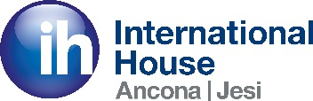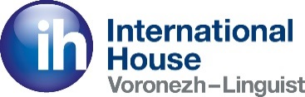ihlondonsig 

Trinity College London 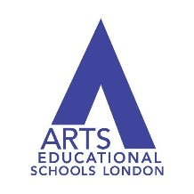 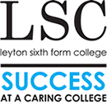

After a whirlwind weekend of theatre, language and international friendships, we can now look back at what was an incredible collaboration - the first **International Playhouse** project: **“Shakes-Share”**.

This vibrant educational event saw three schools, three cultures and three languages come together to share their passion towards theatre and learning. The project involved International House Ancona & Jesi, International House Voronezh, International House London, Leyton 6th Form College, The Arts Educational Schools London, Trinity College London and International House World Organisation (IHWO).

The weekend of the 11th – 13th November saw around 50 students from Italy, Russia and the UK come together in London to participate in dramatic and linguistic exchanges as well as perform a mixture of existing theatre projects. With 2016 celebrating the 400th anniversary of the life and death of Shakespeare, the central theme of the project was Shakespeare’s works and the influence they have carried through to this day. Each participating school group had already created its own Shakespeare-themed project locally, but joined together for a weekend of inter-cultural cooperation. Students participated in a day of drama workshops at IH London along with local students from Leyton 6th Form College, and a range of exciting activities were hosted by Arts Educational Schools’ tutors, as well as the directors of the Italian and Russian theatre projects.

This was followed by an afternoon of sensational Shakespeare performances at Leyton 6th Form College. International House Ancona and Jesi delivered a fun-filled adaptation of The Tempest, displaying how comedy can speak all languages. International House Voronezh performed a modern twist on A Midsummer Night’s Dream, weaving in some brilliant Shakespearian sonnet rap. Leyton 6th Form College closed the event with a magnificent interpretation of Macbeth, performing with true dramatic flare.

Lucy Horsefield, COO of IHWO said *‘We are extremely pleased with the outcome of this successful event. The weekend showcased not only the wonderful talent of the students, but was also a rewarding display of how working together and sharing languages and culture can open up so many opportunities to us all, which embodies the true spirit of the International House network.’*

Trinity College London, whose range of exams is designed to enhance real-world communication skills and include English language, drama and music, was an enthusiastic partner of the Shakes-Share project: *‘The connection between drama, language and communications skills is a rich and fascinating area for exploration with students and teachers’*, said Trinity’s drama academic specialist, John Gardyne. *‘The insights, discoveries and enjoyment that we all shared on this project will remain with us all for a long time and will, we hope, provide a basis for further collaborations in the future.’*

Trinity’s Director of Europe, Andrew Freeman, said he is *‘delighted that Trinity have been able to work closely with IH to bring students from Russia, Italy and the UK together through such a fun project and one that reinforces the belief that integrating drama has a real impact on students’ English language skills and their wider learning and development.’*

All students who took part received a certificate of participation along with feedback from Trinity’s expert assessment team.

Natalia Bayrak, Head of Teacher Training and Development at International House Voronezh said: *‘Although it seemed very ambitious at first, everything that took place from tours and receptions to workshops and performances went much beyond our wildest expectations. What particularly impressed me, however, was how many wonderful people were involved in our project - Trinity, Arts Ed, and our wonderful colleagues from IH London and IH World. We truly felt a part of the International House family with so many schools supporting us. We hope this is just the beginning of something beautiful that all IH schools can be a part of.’*

*‘I can't be more grateful and thankful for having had the opportunity to be part of the very first International Playhouse project, Shakes-Share, and with this I give my most biggest thanks to all the staff that made this wonderful experience possible: to IHWO for believing and sharing this dream with me, to IH Voronez and to Trinity College London.* *Being able to perform in London and take part in amazing workshop during Shakespeare's 400th anniversary was a breathtaking experience for me. Sharing theatrical knowledge and the love for the Bard with directors and drama teachers from other parts of the world was a real dream come true’* said Giuseppe Romagnoli, director of IH Ancona & Jesi.

The warmth and kindness exchanged between the students and contributors to the event is something that will be cherished for years to come. We anticipate that this is just the beginning, and that **International Playhouse** will continue to develop and grow.

**A summary of the participating groups and projects**

**International House Ancona & Jesi – The Victoria Company (Italy)**

Project: “Shakespeare in a Box III” *(Title of work revisited: “TMPST- The Tempest Vogued”)*

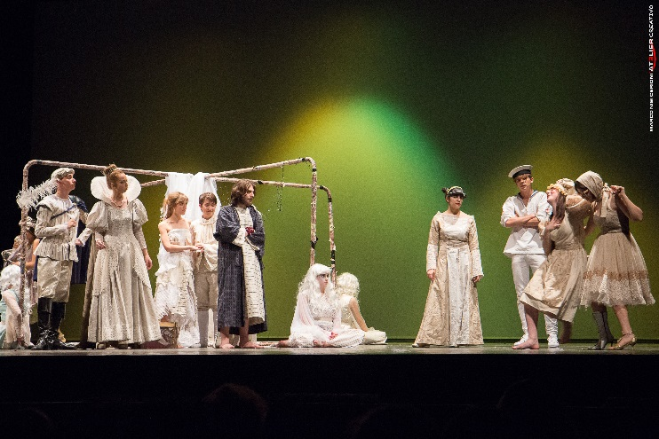An original production directed by Fiorenza Montanari and created and performed by students of IH Acona & Jesi at the Pergolesi Theatre on the 23rd of April, 2016. This bilingual (English-Italian) play combined three intertwining components: Shakespeare’s “The Tempest”, the poetry of Giovanni Pascoli and the music of Madonna. Although these three worlds might appear completely unrelated, the final product was a successful combination of culturally valuable topics that were relevant to the student’s studies and age groups.

The production explored the themes of the relationship between man and nature, the conflict between father and daughter, the momentum towards the profanation of what is holy to the previous generation, magic and the supernatural, the invisible force of music, ‘the New World’ and the theme of immigration. The production was supported by the Associazione Culturale Victoria (A.C.V.), a local organisation which promotes the appreciation of multicultural and multilingual activities in the region.

**International House Voronezh (Russia)**

Project: “Shakespearia”

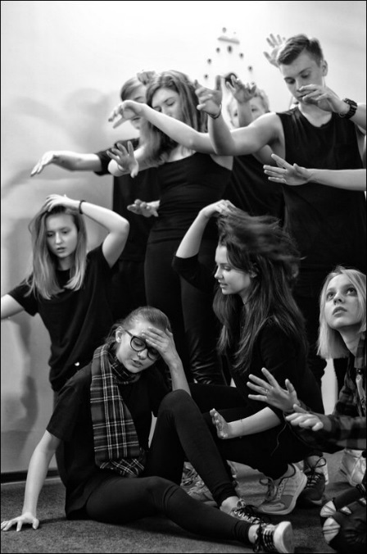A project initiated by a prominent local actor, Kamil Tukaev, this educational drama space exposed teenagers to Shakespeare’s masterpieces in their original versions through acting and learning. Regular classes involve drama, body and voice, language and team-building activities, taught by a team of top professionals.

As part of this endeavour, a group of 16 teenagers aged 13-18 started working on their own version of Midsummer Night’s Dream in January 2016, and in April they performed at the international youth drama festival in Gent. Here they took part in workshops, met their young colleagues from abroad and enjoyed being together as a group.

The production was a 45-minute piece, presenting one of the plot-lines from Midsummer Night’s Dream (the complicated love story of 4 teenagers). The text, a joint creation of the director and actor Kamil Tukaev and Natalia Bayrak, the project’s language consultant and teacher, is a modern English teenage-language adaptation of the original text (with the story “retold” in verse) combined with pieces of the original text, sonnets, modern and original songs and music. The actors “swap”, so the same part is played by several actors, enforcing the “chaos” element, however, the strong body-language focus helps keep the play very accessible.

**Leyton 6th Form College (London)**

Located in North East London, the college’s mission is: *“Working within a safe, welcoming and stimulating environment, which embraces diversity and promotes respect, we help students fulfil their academic potential and become thinking, questioning and caring members of society.”* With excellent facilities including a state of the art theatre and rehearsal studios, Leyton College will be the venue for the Shakes-Share project performances. A group of Leyton College students will participate in the Saturday workshops and will perform their version of Macbeth alongside the performances from IH Ancona and Jesi and IH Voronezh on Sunday.

For more information visit <http://www.leyton.ac.uk/>

**The Arts Educational Schools London**

Arts Educational Schools London (ArtsEd), based in Chiswick, is recognised across the globe as a centre of excellence for training in the performing arts. ArtsEd was founded in 1939 when Grace Cone and Olive Ripman merged two existing schools with the ambition of preparing young people for professional careers in the theatre, a principle that has remained at the forefront of ArtsEd’s training ever since.

ArtsEd offers a three year Acting BA Hons course which prepares students for stage and screen. The Musical Theatre BA Hons course is widely regarded as the best in its field within the UK. The school offers a range of undergraduate, postgraduate and part-time courses, providing exceptional training to all ages and abilities. The Independent Day School and Sixth Form nurtures pupils from the ages of 11-18 with an outstanding vocational and academic education.

For the Shakes-Share project, ArtsEd tutors will be involved in the programme of Shakespeare themed drama workshops planned on Saturday, and some students will be contributing performances on Sunday.

Named ‘School of the Year’ at The Stage Awards 2016. For more information please visit [www.artsed.co.uk](http://www.artsed.co.uk)

**International House World Organisation**

International House is one of the largest and oldest groups of language schools in the world, founded in 1953 when the first school was opened by John and Brita Haycraft in Cordoba, Spain. International House pioneered qualifications in teacher training and today’s CELTA is based on the original International House Certificate in Teaching English.

The International House World Organisation (IHWO) was formed in 2003 to manage and support the global network of IH schools. There are currently 160 affiliated private language schools in 52 countries, spanning every continent. Although many of schools teach English there are a total of 33 different languages taught across the network.

Every year, International House schools teach over 202,000 students and in 2015 around 140,000 students took an external language exam through an IH school.

For more information see <http://ihworld.com>

**Trinity College London**

Trinity College London is an international exam board with a rich heritage of academic rigour and a positive, supportive approach to assessment. We provide recognised and respected qualifications across a unique spectrum of communicative skills — from music, drama and arts activities to English language — at all levels.

Trinity exams and assessments are specifically designed to help students progress. They inspire learners and mark their achievement at each stage of their development and at all levels of competence. We also encourage candidates to bring their own choices and interests into our exams — this motivates students and makes the assessment more relevant and enjoyable.

At the heart of Trinity’s work is the support we provide for teachers, both in terms of specific support for teachers preparing candidates for our exams, and more general teacher development. Our work with teachers is supported by a growing international network of relationships with key education institutions. This ensures that our teachers have access to the best professional development available.

## International House World Organisation and Trinity College London have recently signed a relationship agreement and are working closely together to enable more of IH’s high quality schools to become Trinity exam centres.

For more information visit www.[trinitycollege.com](http://www.trinitycollege.com)

 